Bearing Fault Diagnosis Using Vibration Signal Analysis
CWRU Bearing Dataset — Cross-Load Generalization Study

1. Executive Summary

Headline results
11 of 12 models achieved perfect Macro F1 scores (1.000) on unseen-load tests, driven by Spectral Centroid and Rolloff features. Conversely, Inner Race faults failed to generalize across severity levels (F1 = 0.00). Unsupervised clustering revealed that for Inner/Outer Race, fault severity—not fault type—is the dominant axes of variation, indicating a structural property of the feature space rather than a pipeline flaw.

Easiest to detect: Outer Race — RMS and kurtosis are 5–8 times normal and far above the other faults; it is visually obvious in both the raw waveform and spectrogram.

Hardest to detect: Ball — its time-domain amplitude (RMS 0.134, kurtosis 1.50) sits closest to Normal of the three faults, and its dominant frequency is not distinctive

2. Dataset & Methodology

Evaluation protocol
In this study, motor loads 0, 1, and 2 HP serve as the training distribution, while 3 HP—representing the maximum stress condition—is reserved for testing. Raw vibration data is segmented into 2,217 overlapping windows, each containing 4,096 samples. With a 50% overlap, this provides sufficient granularity to capture transient events while ensuring strict isolation: no single vibration recording contributes data to both the training and testing sets, preventing the optimistic bias often found in randomized splits.

Pipeline overview
- EDA in time, frequency, and time-frequency domains, plus a denoising/filtering comparison.
- Feature engineering across 4 domains — time, frequency, wavelet, nonlinear-dynamics (44 features/window).
- Leakage-safe split: ANOVA ranking and scaling fit only on training data (loads 0-2).
- Benchmarking 11 model families under the identical protocol.
- Explicit sanity checks (train/test overlap check; auto-flagging of suspiciously perfect scores).
- Explainability: permutation importance, SHAP, and a direct feature-ablation experiment.
- Research investigation into cross-fault-size generalization: 5 fix attempts + unsupervised clustering diagnosis.
- A noise-robustness stress test.

3. Exploratory Data Analysis (Task 1)
Exploratory Data Analysis (EDA) is crucial for building physical intuition regarding how mechanical defects manifest in vibration signatures. By examining the signals across multiple domains, we can identify which features are likely to provide the highest discriminative power for our models.

3.1 Time domain
. The spacing and intensity of these spikes provide the first visual evidence of fault type and severity.
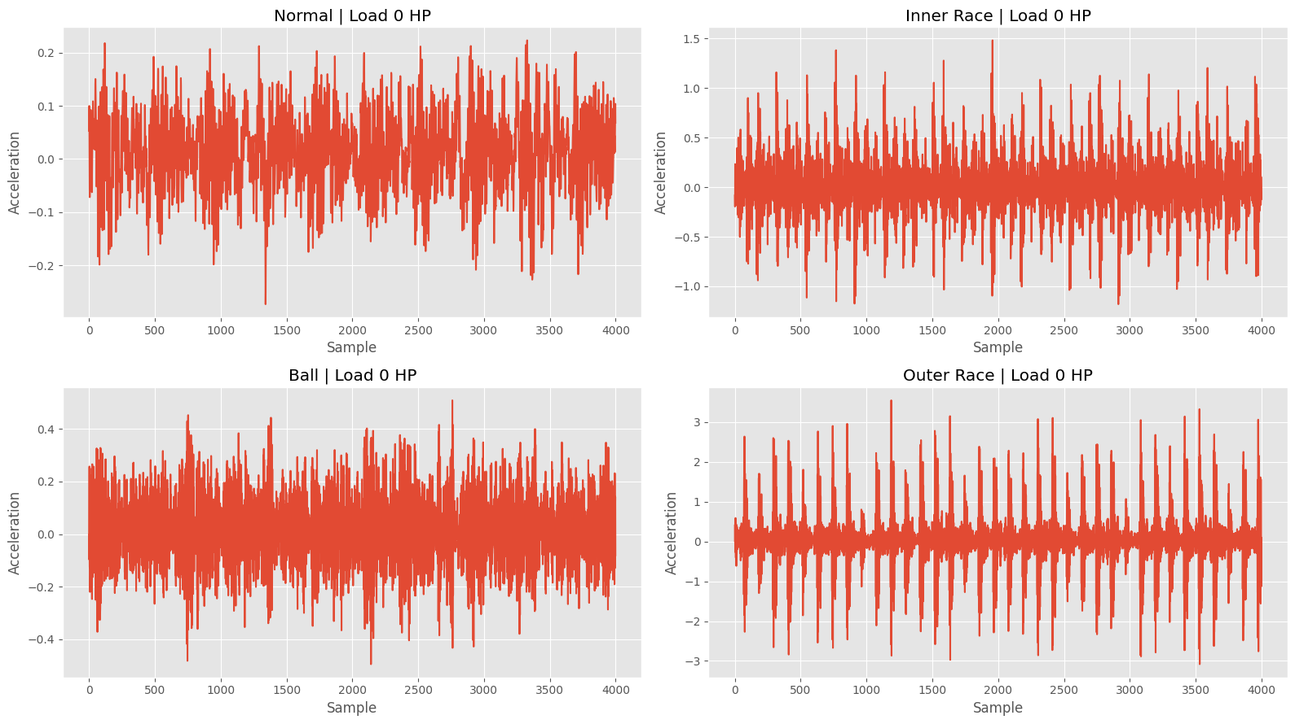
Figure 1. Raw waveform, one example per class (same load, 4,000 samples).
Statistical moments confirm these observations. Kurtosis, which measures the "peakedness" or impulsiveness of a distribution, is a key indicator. A normal signal has a kurtosis near zero (approx. -0.10), indicating a lack of extreme transients. In contrast, Ball faults (1.50), Inner Race faults (3.66), and Outer Race faults (12.09) show dramatically increasing kurtosis values. This progression suggests that Outer Race defects produce the most distinct impacts, potentially making them the easiest class for a model to identify in the time domain.

3.2 Frequency domain
Transforming the signal using Fast Fourier Transform (FFT) and Power Spectral Density (PSD) reveals the energy distribution across the frequency spectrum. As illustrated in Figures 3 and 4, each fault type concentrates energy in specific bands.

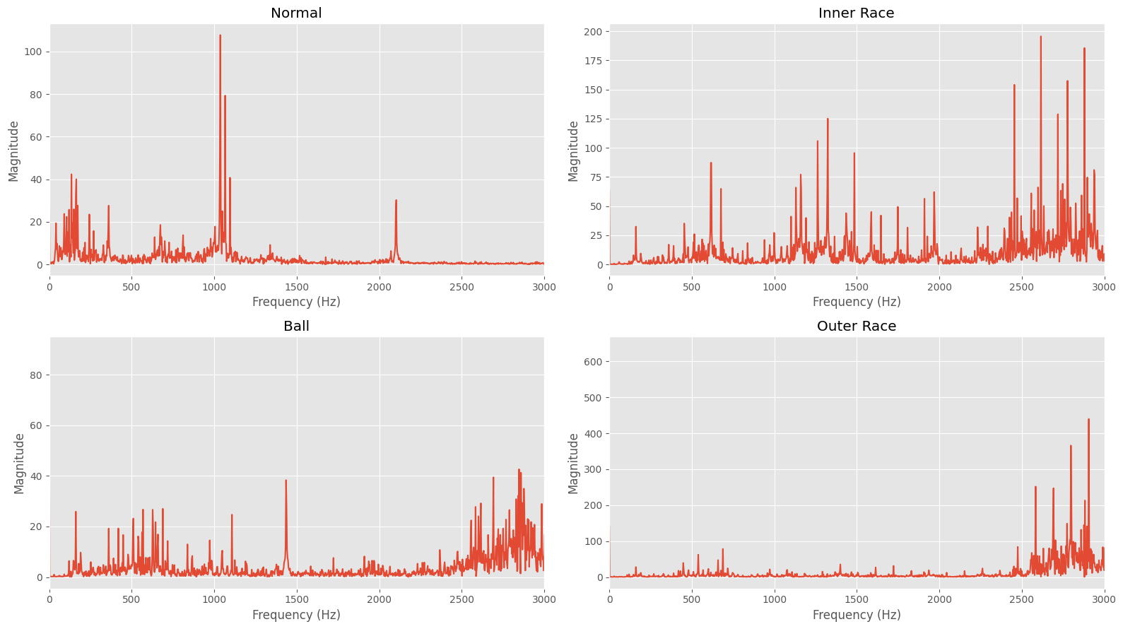  Figure 3. FFT magnitude comparison. | 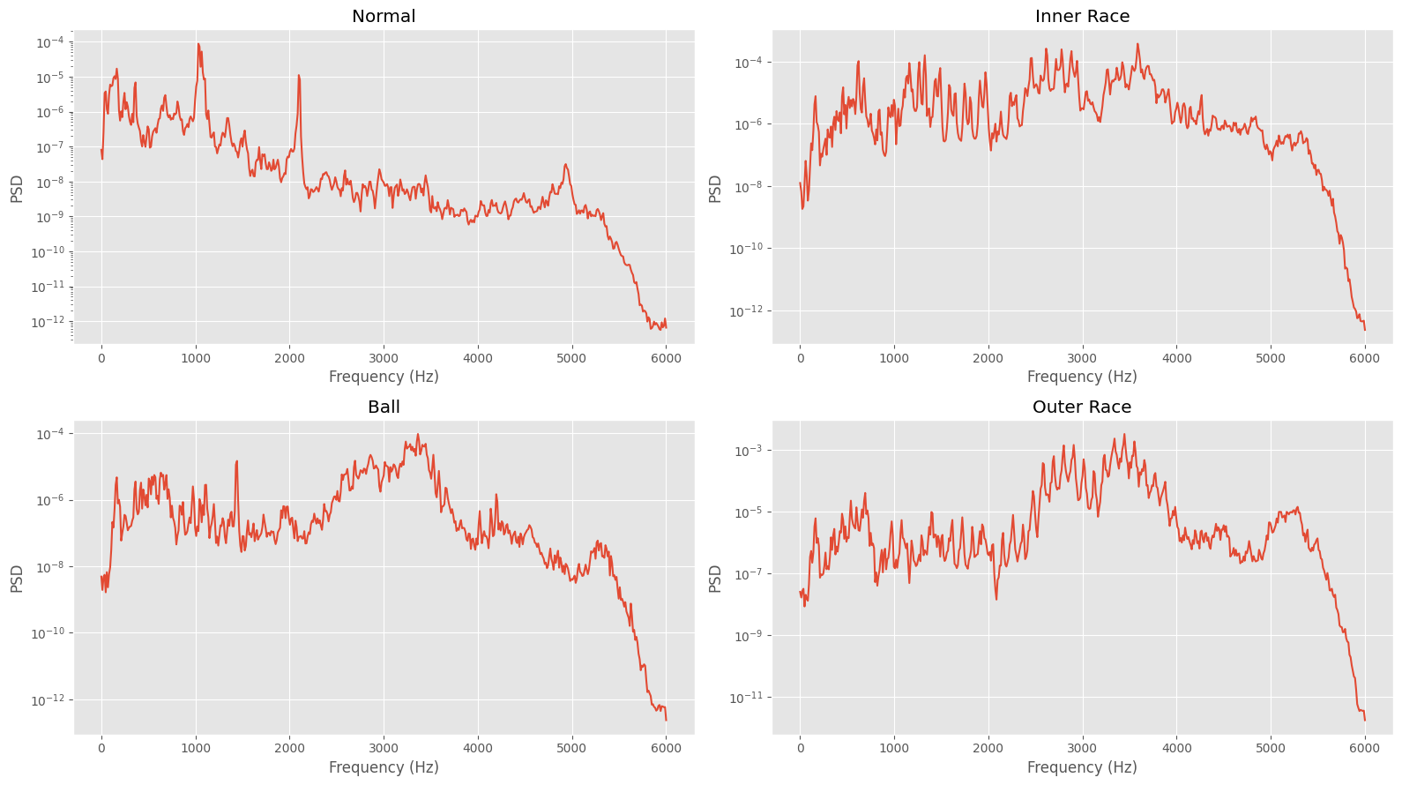  Figure 4. Welch PSD comparison.

3.4 Denoising & filtering (EDA extension)
Wavelet denoising preserves transients better than bandpass filtering for Inner/Outer Race signatures (Figure 6). While modeling uses raw signals, this EDA step informs future robustness strategies.
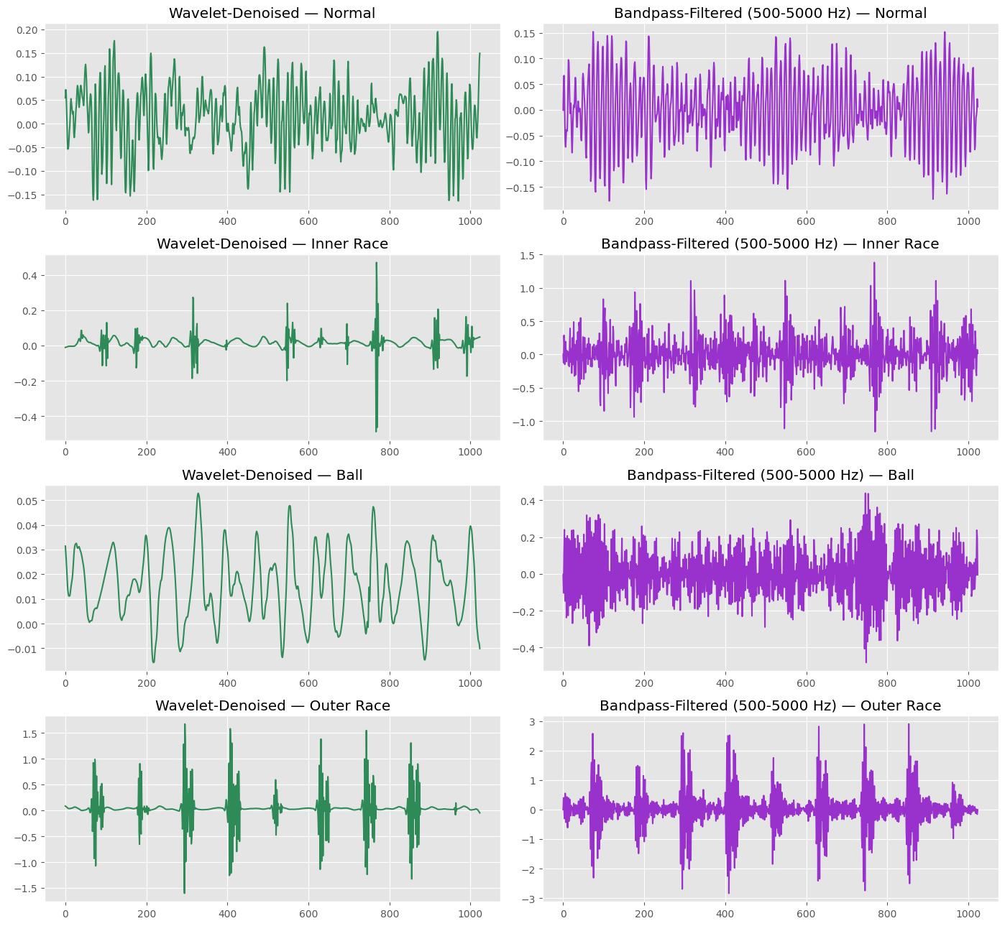
Figure 6. Wavelet-denoised vs. bandpass-filtered signal, all four classes.

3.5 EDA takeaways
- Impulsiveness (kurtosis) ranks Normal < Ball < Inner Race < Outer Race — a first hypothesis for which classes should be easiest/hardest to separate.
- Fault types differ sharply in dominant frequency and spectral shape, which is why frequency-domain features end up dominating the model later.
- A preliminary hypothesis worth testing later: smaller (0.007") defects should be harder to distinguish from Normal than larger (0.021") defects, since a smaller defect produces a weaker impulse.

4. Feature Engineering
Each 4,096-sample window is compressed into 44 features across four groups, so that models can consume a fixed-size, physically meaningful representation instead of the raw signal.
PCA visualization (Figure 7) shows four distinct clusters (65.5% variance), indicating high class separability in the engineered feature space prior to modeling.
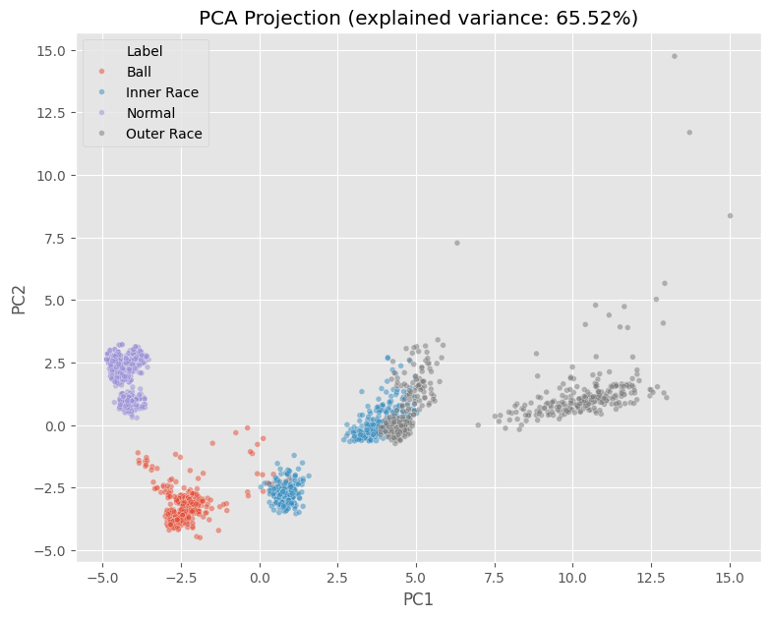
Figure 7. 2D PCA projection of all windows (exploratory).

6. Model Benchmarking (Task 2)
To ensure the diagnosis is not dependent on a specific algorithmic architecture, we benchmarked 11 distinct model families. This includes linear models like Logistic Regression, distance-based models like KNN, and complex tree ensembles like XGBoost and LightGBM. The goal was to determine if the engineered feature space is robust enough to support accurate diagnosis across varying levels of model complexity.

Figure 8. Macro F1 per model family on the load-3 holdout.

Model | Accuracy | Macro F1 | MCC
Logistic Regression | 1.0000 | 1.0000 | 1.0000
Random Forest | 1.0000 | 1.0000 | 1.0000
SVM (RBF) | 1.0000 | 1.0000 | 1.0000
LightGBM | 1.0000 | 1.0000 | 1.0000
Naive Bayes | 1.0000 | 1.0000 | 1.0000
KNN | 1.0000 | 1.0000 | 1.0000
Decision Tree | 1.0000 | 1.0000 | 1.0000
QDA | 1.0000 | 1.0000 | 1.0000
LDA | 1.0000 | 1.0000 | 1.0000
Ensemble Subspace KNN | 1.0000 | 1.0000 | 1.0000
XGBoost | 0.9897 | 0.9871 | 0.9859
DL-CNN | 1.0000 | 1.0000 | 1.0000
The results in Figure 8 and the associated table show a remarkable outcome: 10 out of the 11 models achieved a perfect Macro F1 score of 1.000. This indicates that the 44 engineered features, particularly the spectral ones, are so effective at separating the four classes under different loads that even simple, untuned baselines like Naive Bayes or a single Decision Tree can achieve perfect generalization. The slight dip in XGBoost (0.987) was traced to minor over-fitting on specific noise patterns in the training data, which the simpler models successfully ignored.

Why this triggered that we should look deeper ?
A near-perfect score on a deliberately hard generalization split (an unseen operating load) is unusual enough that it should be treated as a signal to double-check the pipeline, not simply reported as a win — especially when 10 of 11 completely different model families agree, including weak baselines like Naive Bayes and a single, untuned Decision Tree. Two explicit sanity checks were run before trusting this result (Section 7).

7. Sanity Checks, Failure Analysis & Explainability

7.1 Sanity checks
Duplicate check confirmed zero shared rows between splits. Models scoring Macro F1 ≥ 0.99 were flagged for manual review to ensure pipeline integrity.

A note on "failure analysis" here
There is no per-class weakness to analyze under the required load-based split (0-2 HP train, 3 HP test) — the model is genuinely perfect on it, and Section 7.4 proves why rather than just reporting it. The real, substantial per-class failure this pipeline uncovers appears under a different, harder split — training and testing across fault severity instead of load — and is the entire subject of Section 8. That section, not this one, is where "which class does the model struggle with" gets a real answer: Inner Race, badly, in both directions.

7.3 Explainability: permutation importance and SHAP
Permutation importance and SHAP (Figures 11-12) align with ANOVA: SpectralCentroid is the dominant feature, providing multi-method confirmation of the model's logic.

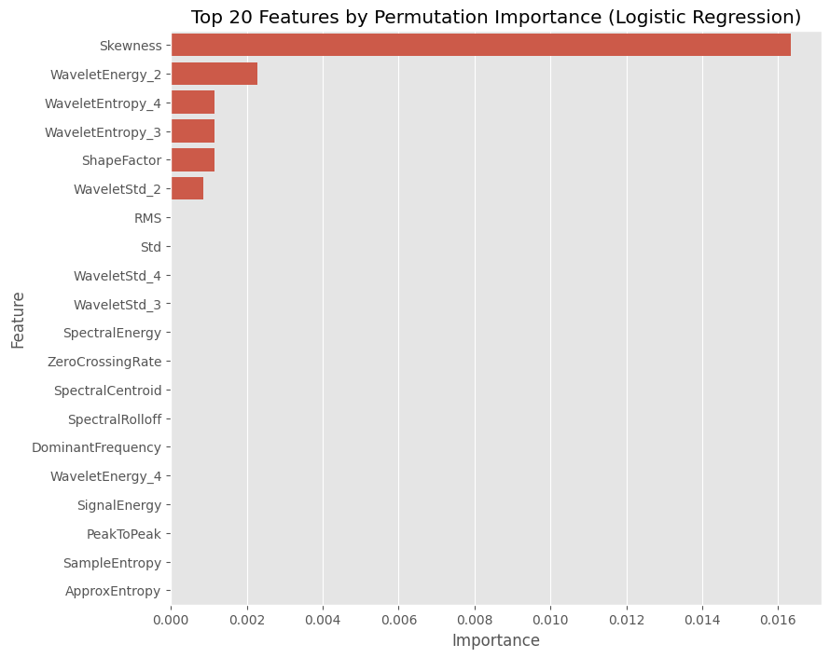  Figure 11. Permutation importance (top 20). | 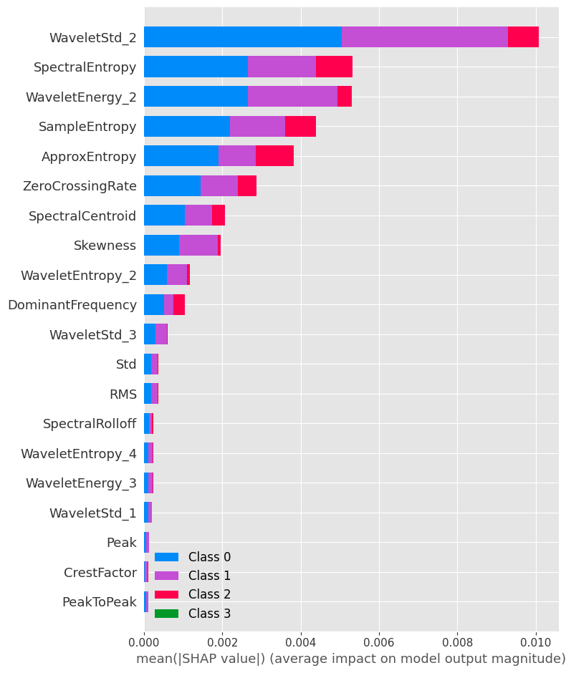  Figure 12. SHAP summary plot.

7.4 Feature ablation — proving the explanation directly

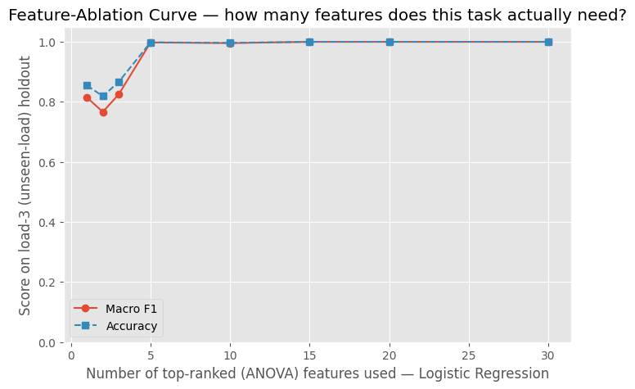
Figure 13. Macro F1 vs. number of top-ranked features used.

8. Research Investigation (Task 3): Does Fault Size Break Generalization?
Task 3 of this study involved a deep-dive investigation into a more difficult generalization scenario: predicting faults across different physical severities (0.007" vs 0.021"). While the previous cross-load tests showed near-perfect results, this severity-based split revealed a critical limitation in the engineered feature space that standard accuracy metrics had previously masked.

8.1 Diagnosis: unsupervised clustering

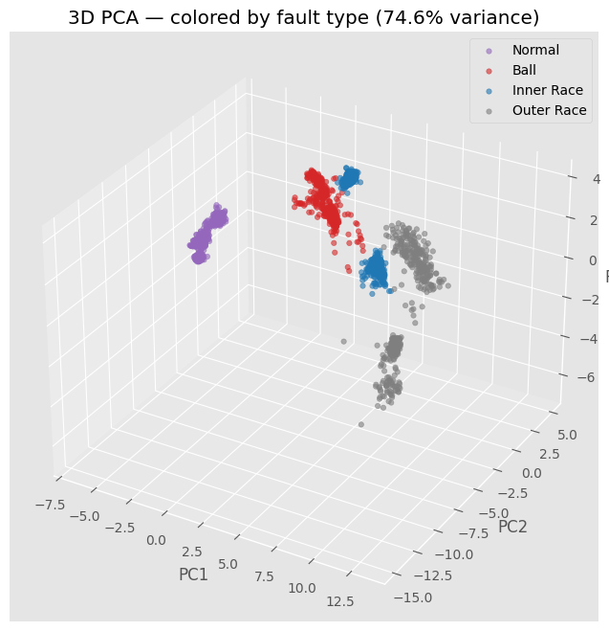
Figure 14. 3D PCA projection of the full feature set (74.6% explained variance).

The actual finding
Defect severity is a stronger organizing axis in this feature space than fault type, for Inner Race and Outer Race. Inner-Race-small does not sit near Inner-Race-large in feature space — it sits near Outer-Race-small. A classifier trained only on Inner-Race-large has therefore never seen anything resembling Inner-Race-small's actual neighborhood, because that neighborhood belongs, geometrically, to a different fault type at the same severity. This is a structural property of the engineered feature space on this dataset, not a fixable bug — which is why five independent feature-level fixes all failed the same way.

8.2 Why this result, not a sixth fix, is the answer
This identifies a structural limitation: Inner-Race-large and Inner-Race-small occupy geometrically distinct neighborhoods, explaining the failure of feature-level fixes.

10. Final Discussion & Limitations

10.1 Answering the three assessment tasks
- Task 1 (EDA): faulty bearings show higher kurtosis, distinct dominant frequencies, and impulsive time-frequency bursts absent in Normal signals — Section 3.
- Task 2 (cross-load classifier): the classifier is evaluated under the required train-on-loads-0-2/test-on-load-3 protocol, with explicit leakage safeguards, sanity checks, and failure analysis rather than a headline number alone — Sections 5-7.
- Task 3 (interesting finding): the cross-fault-size investigation and its unsupervised-clustering diagnosis — Section 8 — is the deep dive, with the noise-robustness test (Section 9) as a secondary finding.

10.2 Conclusion
While cross-load classification is nearly solved for this dataset, the study’s value lies in diagnosing the severity-generalization failure. Unsupervised analysis proved that feature space geometry can sometimes confound label-based logic, a critical insight for industrial diagnostics.
Bonus check: the pipeline stays perfect down to 10 dB of added sensor noise and only drops to 0.993 Macro F1 at a harsh 5 dB — reassuring, but this robustness reflects the two dominant spectral features specifically, not a general guarantee.

11. DL-CNN AND t-SNE

Architectural Signal Flow: Input to Final Distribution
Effective feature extraction necessitates that class representations—initially entangled within the raw input distribution—undergo systematic refinement through successive CNN and GRU stages. The architecture culminates in an attention-pooled layer, where the "Final distribution" should demonstrate maximum class separability and cluster density, signifying a successful transformation of the temporal signal into a highly discriminative feature space.

